Solution to Amy’s by Toby McGurk (Year 5, St Johns College School)

Step 1: I worked out how many dots there are in the full set.

I sorted my dominos and counted them in order.
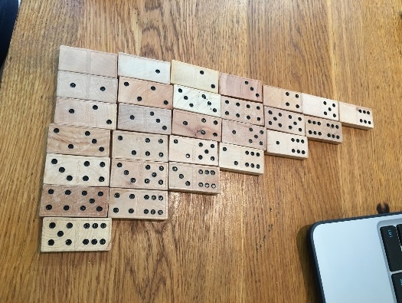

Total number of dots = 168

Step 2: work out how many dots are missing

168-125 = 43

Step 3: put this into four dominos.

Each domino must have roughly 11 dots each

5+6=11
6+6=12
5+5=10
6+4=10

