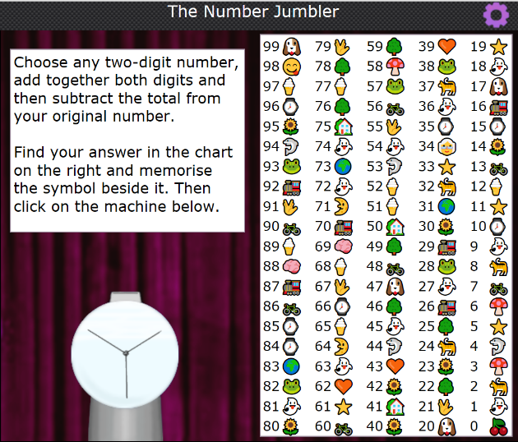
Nrich: The Number Jumbler Solution.
The solution to the number jumbler is what I believe a simple one, it only took me one attempt to realise the computers strategy.
In the picture to the left, there are all of the numbers from 0 to 99, each with a little image to the side of it. The instructions tell you to choose a two-digit number, and those two digits together, then subtract the total from the original number. Then, you have to memorise the little image next to your answer, and the machine will guess it.
For example, if you take 51, you add the 5 and the 1 together, making 6, you then subtract the 6 from the 51 and it leaves you with 45. In this case it is next to a ghost.
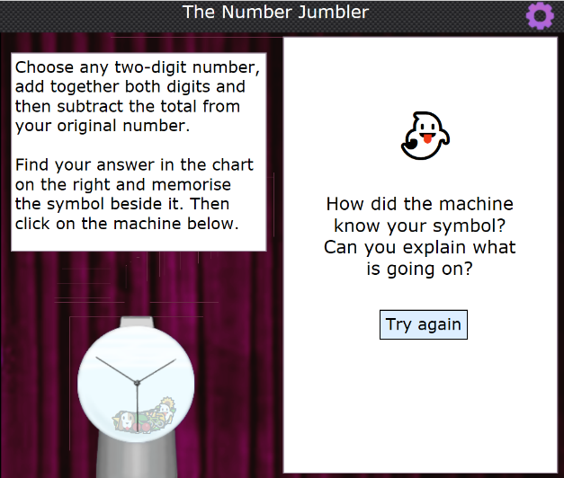
As you can see here, the machine came out with the ghost image, which matches the example I made of 51-6=45.
Why? you may ask. The reason being that all of the two-digit numbers, where you add up the digits then take that total away, have only a few different possible answers, 9 to be exact, and each one of those 9 numbers is represented in this case by a little ghost. You may notice that there is more than 9 ghosts, but I presume that that is there as decoy.
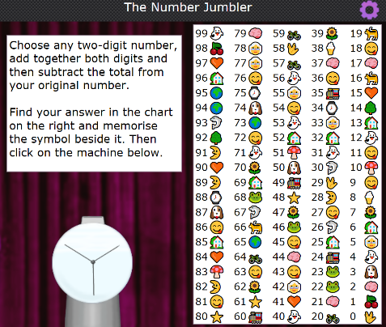
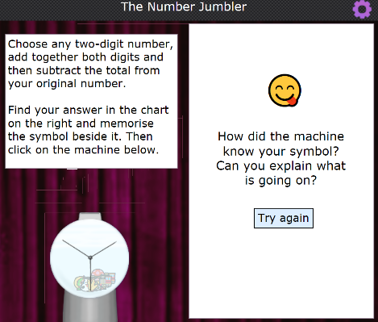
You can take any two-digit number, add the digits together, then take that number away from the original number, it will total to one of the 9 digits, and just to avoid suspicion, the game changes the symbols around so the answer isnt always a ghost.
For example here, the same number (45) is a smiley face, instead of a ghost.
In conclusion, all two-digit numbers, if you add the digits together then take away that from the original number, add up to 9 different numbers. To guess which symbol represents that number, the computer makes all of those 10 nummbers have the same symbol so that it will always guess right.

